**supplementary material**

**Tab.S1 Countries with missing trade data 2001-2015**

|  |  |  |  |  |  |  |  |
| --- | --- | --- | --- | --- | --- | --- | --- |
| **WLD** | SRB |  |  |  |  |  |  |
| **CHN** | SRB | SYR | GIN | ALB | BWA | NIC | MWI |
| **USA** | SRB | CUB | LBY |  |  |  |  |

(b)

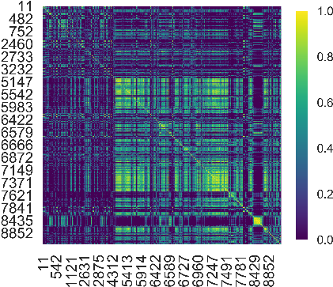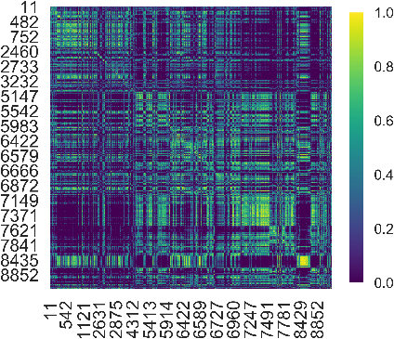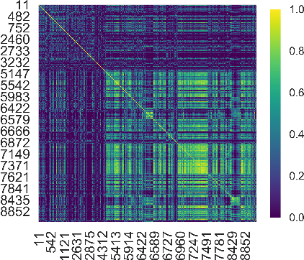

(c)

(d)

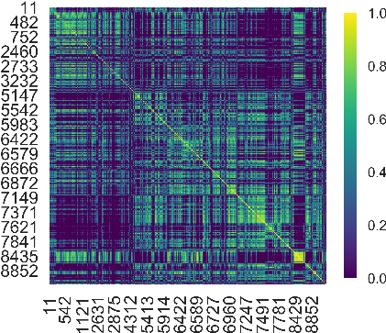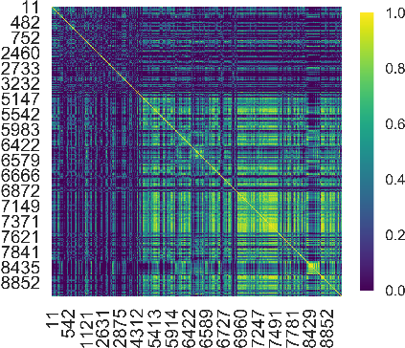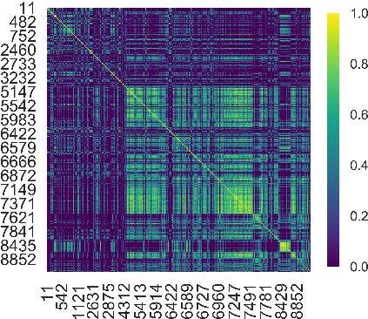

(e)

(f)

(g)

(h)

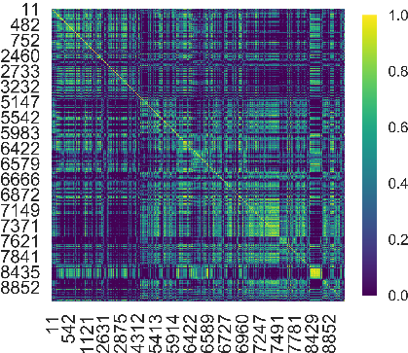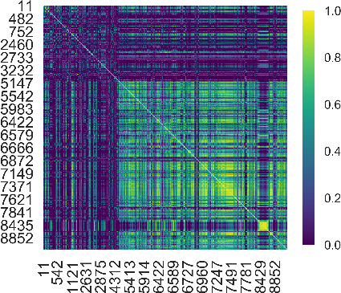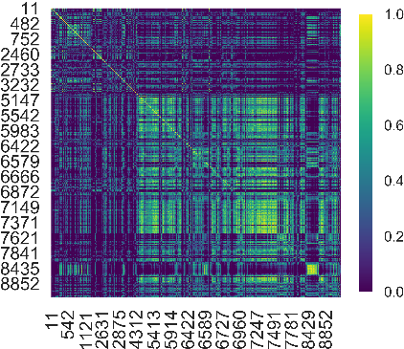

(i)

Fig. S1 Heat map of product proximity for world, China, and the US. (a-c) Heat map of product proximity in the world, China, the US at 2001-2005; (d-f) Heat map of product proximity in the world, China, the US at 2006-2010; (g-i) Heat map of product proximity in the world, China, the US at 2011-2015.

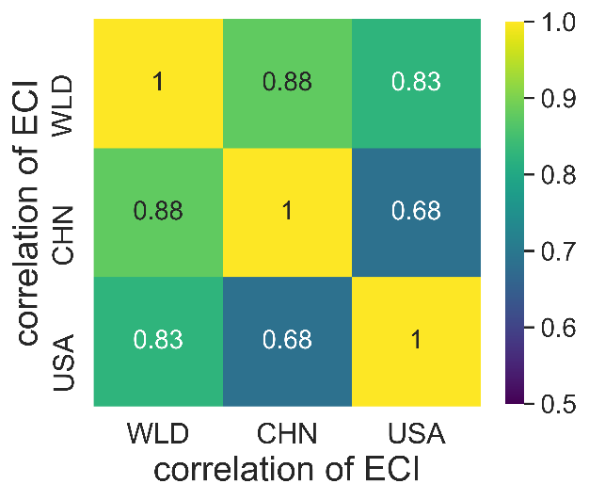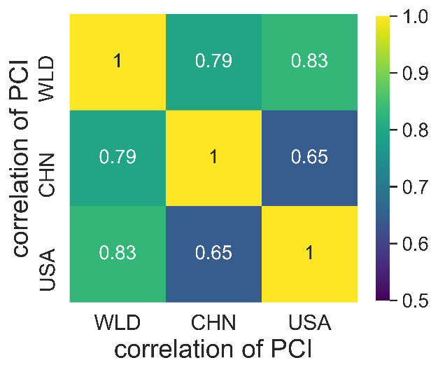

(a)

(b)

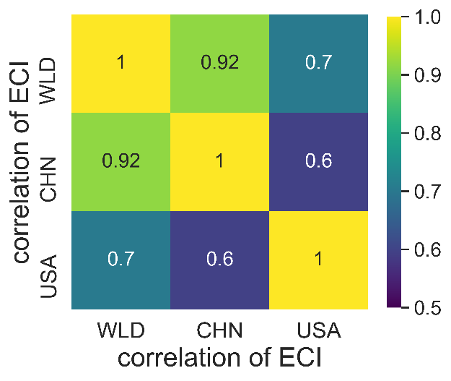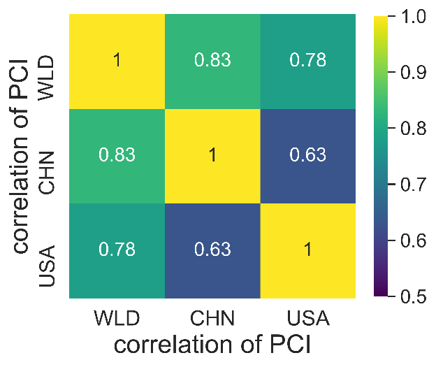

(c)

(d)

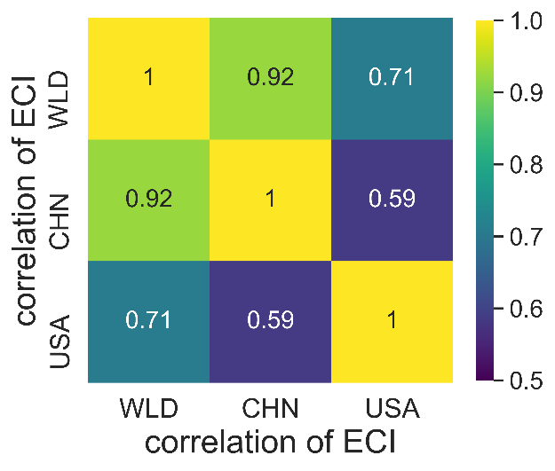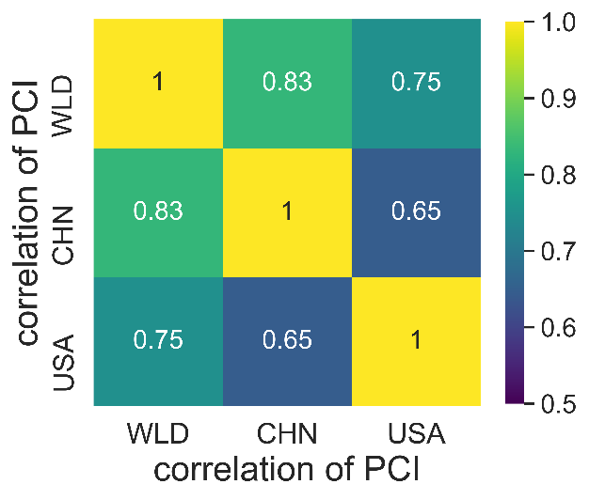

(e)

(f)

Fig. S2 (a-b) Correlation coefficients of ECI, PCI for 2001-2005; (c-d) Correlation coefficients of ECI, PCI for 2006-2010; (e-f) Correlation coefficients of ECI, PCI for 2011-2015.

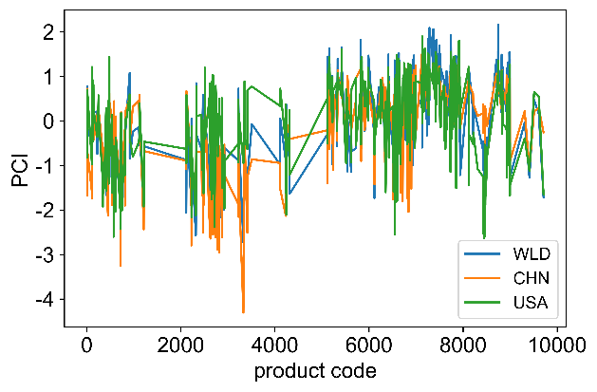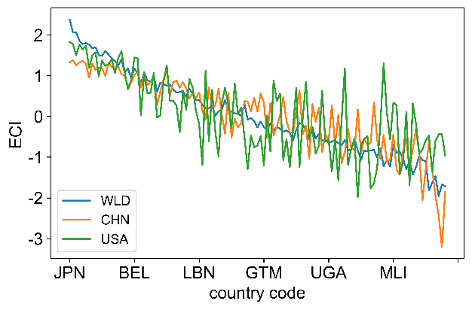

(c)

(d)

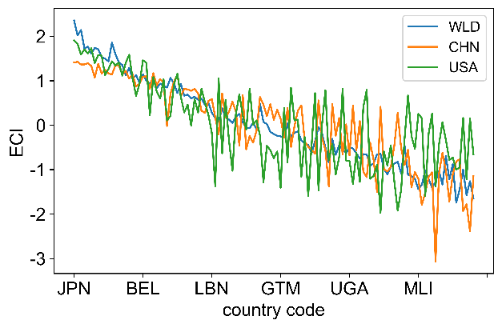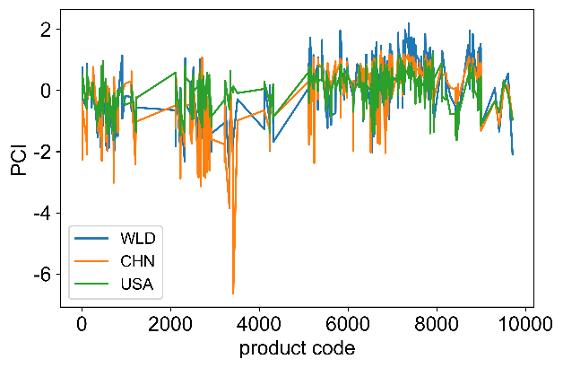

(e)

(f)

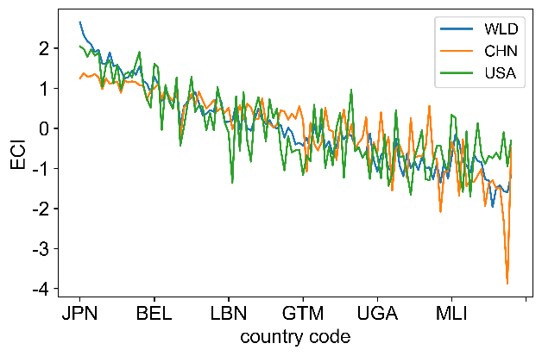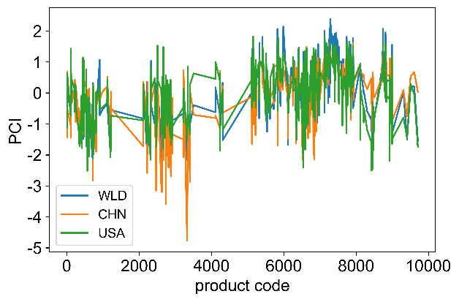

(a)

(b)

Fig. S3 (a-b) Trends in ECI and PCI in the world, China, and the US trade perspective, 2001-2005; (c-d) Trends in ECI and PCI in the world, China, and the US trade perspective, 2006-2010. (e-f) Trends in ECI and PCI in the world, China, and the US trade perspective, 2011-2015.

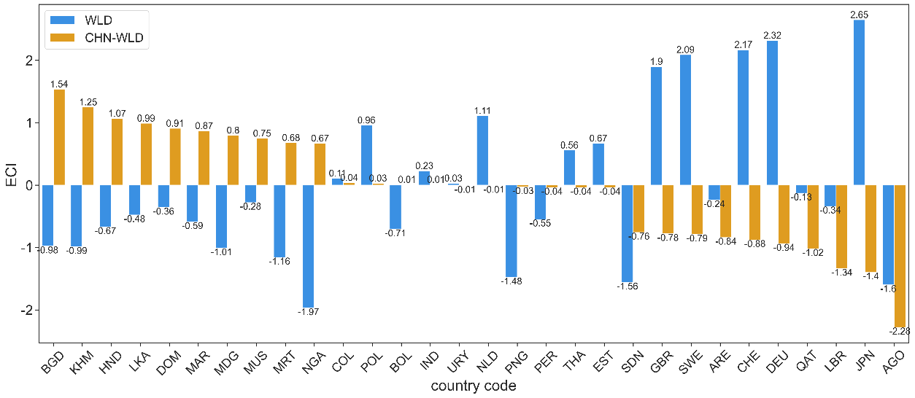

(a)

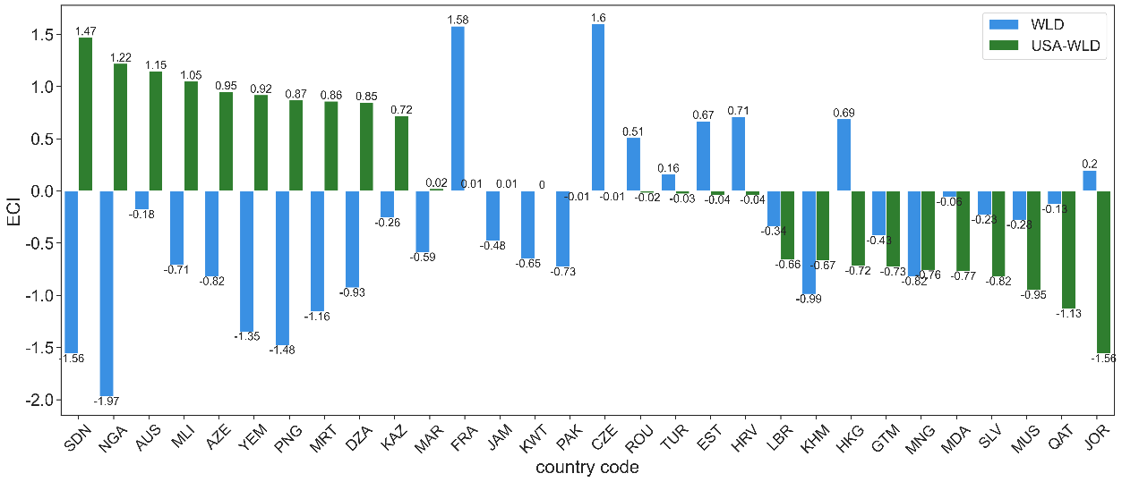Fig. S4 Analysis of economic complexity gap extremes for 2001-2005. (a) Extreme values of the economic complexity gap between China and the world; (b) extreme values of the economic complexity gap between the US and the world.

(b) G)

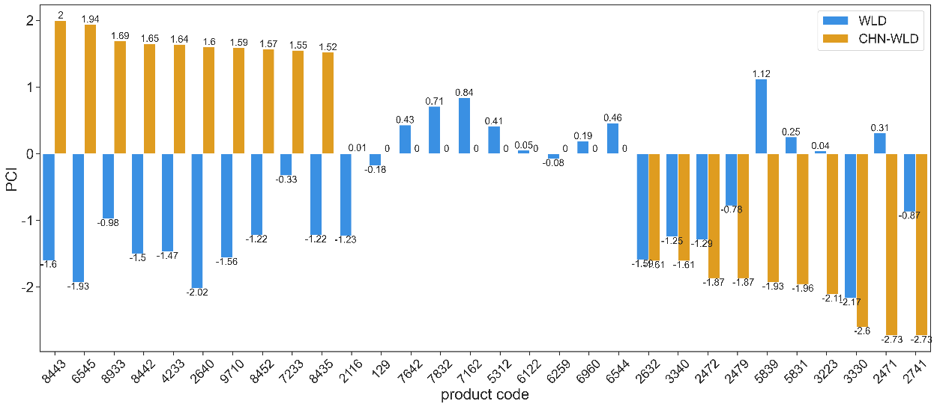

(a)

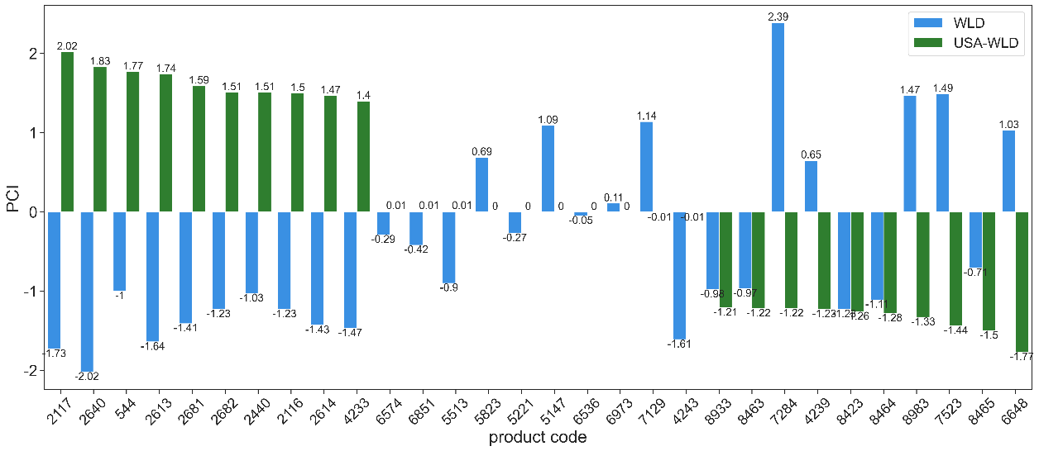

(b) G)

Fig. S5 Analysis of product complexity gap extremes for 2001-2005. (a) Extreme values of the product complexity gap between China and the world; (b) extreme values of the product complexity gap between the US and the world.

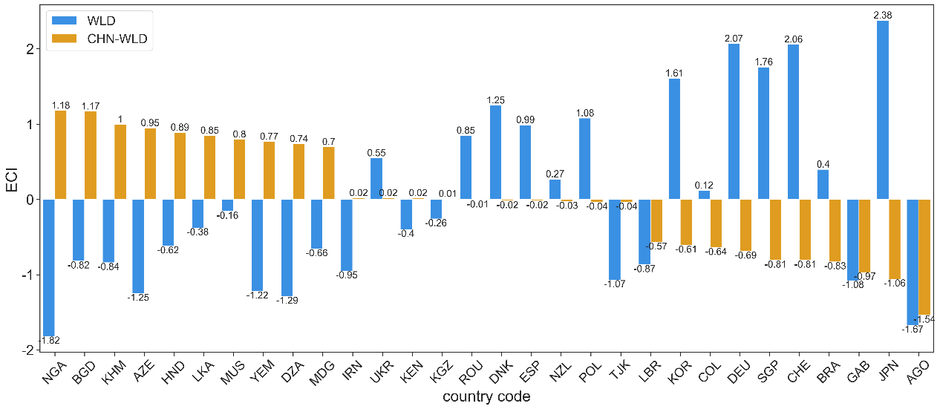

(a)

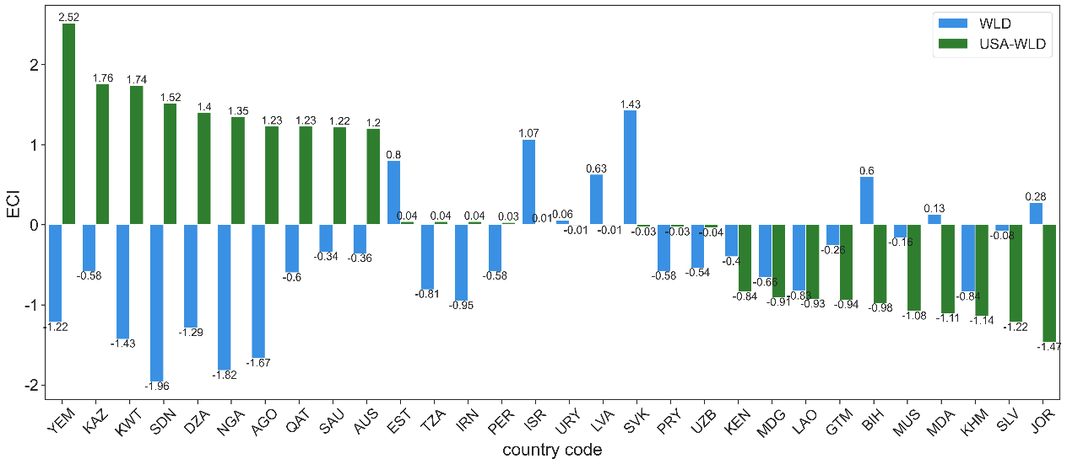

(b)

Fig. S6 Analysis of economic complexity gap extremes for 2006-2010. (a) Extreme values of the economic complexity gap between China and the world; (b) extreme values of the economic complexity gap between the US and the world.

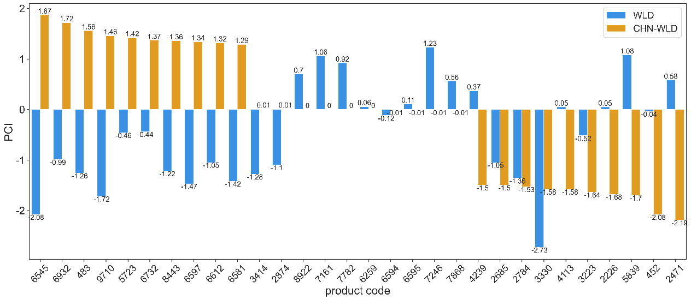

(a)

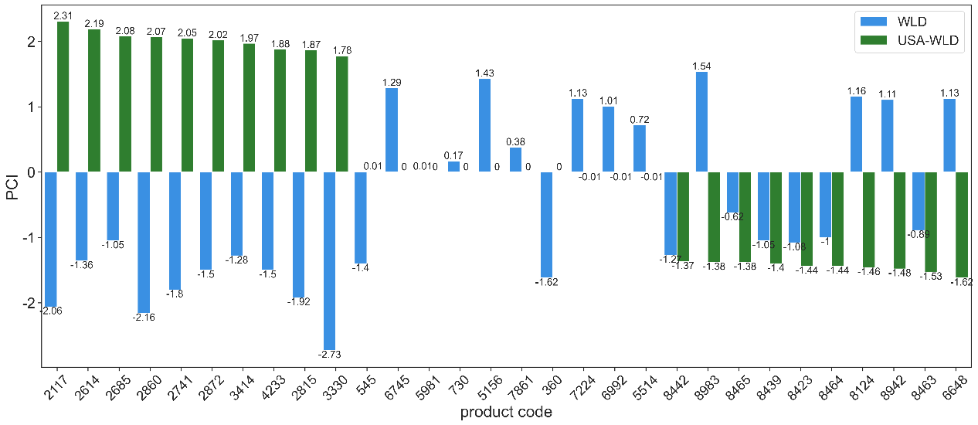

(b)

Fig. S7 Analysis of product complexity gap extremes for 2005-2010. (a) Extreme values of the product complexity gap between China and the world; (b) extreme values of the product complexity gap between the US and the world.

(a)

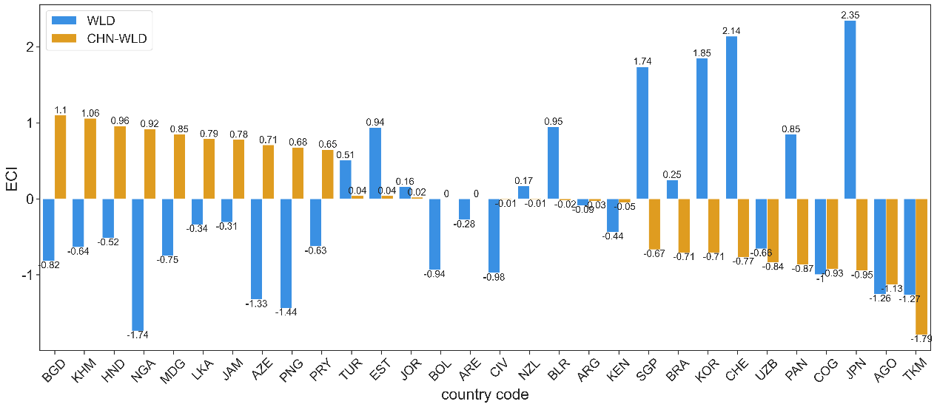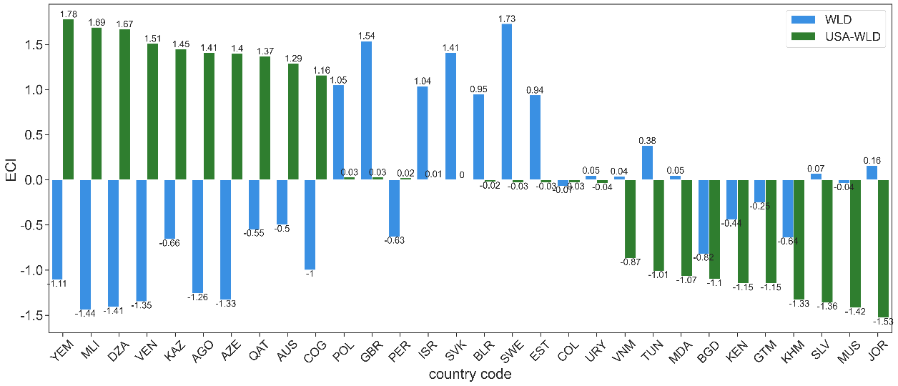

(b)

Fig. S8 Extreme values analysis of economic complexity gap in China and world perspective, 2011-2015 (a), and extreme value analysis of economic complexity gap in US and world perspective, 2011-2015 (b).

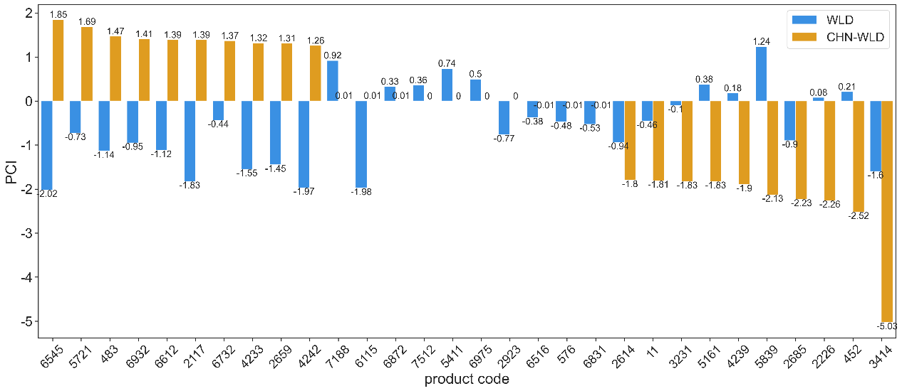

(b)

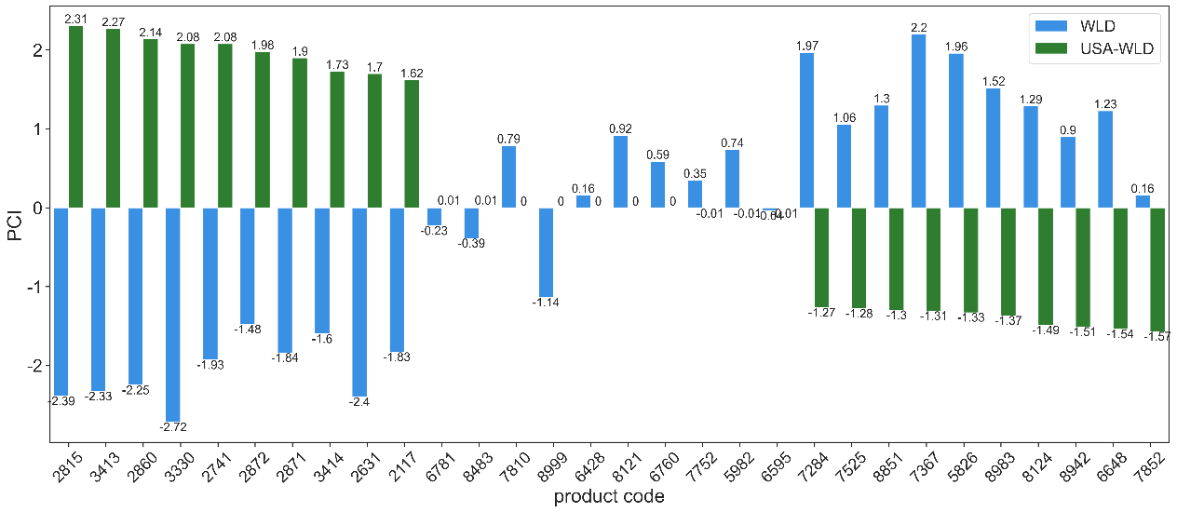

(a)

Fig. S9 Analysis of product complexity gap extremes for 2011-2015. (a) Extreme values of the product complexity gap between China and the world; (b) extreme values of the product complexity gap between the US and the world.